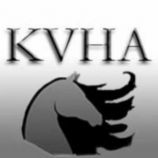
Kanawha Valley Horsemen’s Association PO Box 164 Clendenin, West Virginia 25045
Visit us at: www.kvhahorseshow.com

Kanawha Valley Horsemen’s Association Sponsorship Form 2024

Sponsorship Type: Half Page Ad $150
Full Page Ad $250 Ads will appear in all 5 show programs

Sponsor Name as it will appear in program ____________________________________
Name of Class to Sponsor (if any) __________________________________________
Second Choice (if any)
Barn Affiliation (if any) Do you need assistance with the preparation of your ad? Yes No
Check and sponsorship form can be mailed to the address below.
PayPal is also accepted through the KVHA website at www.kvhashorseshow.com however a completed application form must also be submitted if paying by PayPal.
Your canceled check or PayPal confirmation email is your receipt.

Name of the person financially responsible

Address

Phone Email

Signature Payment Amount $

In addition to great advertising by supporting our horse shows you are also giving our community the opportunity to participate in a sport that has many benefits to our youth. Riders of all ages participate at KVHA shows and need your help to make their horse dreams come true!

